If you are a new applicant to this granting system, please use the technical guides below to:

- Register
- Apply for grants
- Manage your media library and attach files to applications, interim, or final reports
- Complete application processes
- Find additional help

Table of Contents
REGISTER 2
BEGIN AN APPLICATION 3
WORK ON AN EXISTING APPLICATION 4
MEDIA LIBRARY SELECTION PAGE 5
TROUBLESHOOT MEDIA LIBRARY 6
NEXT STEPS 7
HELP AND GUIDANCE 8

*If you are viewing this document in a web browser, you may need to open or download it as a PDF for the Table of Contents and other links to work.

REGISTER

In order to utilize our online granting system, you will need to register. You will be able to access our home page when you first navigate to our site; however, if you leave the home page, you will be prompted to register or login. You will be able to view custom navigation pages, such as Resources or Grant Guidelines shown below, but you will not be able to edit your profile, access applications, or manage your media until you log in.
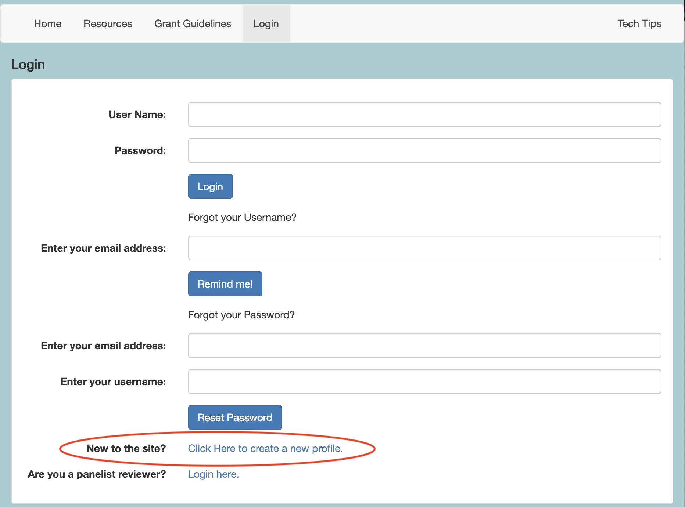
- Navigate to our new GO Smart portal at the URL that was provided to you.

- Locate and click the link at the bottom of the Home or Login page that says "New to the site? Click Here to create a new profile."

- Agree to the terms, answer the questions on the registration page, and Save to create your profile.

- If you want multiple people to work on a single application, they will all need to login with the same username and password.

- You can always update any information of your profile. Once logged in, click Edit Profile in your navigation bar to access and edit your registration information.

- Use the retrieval tools on the Login page if you forget your username or password.

BEGIN AN APPLICATION

When you are ready to work on a grant, you will use your Current Programs & Applications tab to find the appropriate application(s).
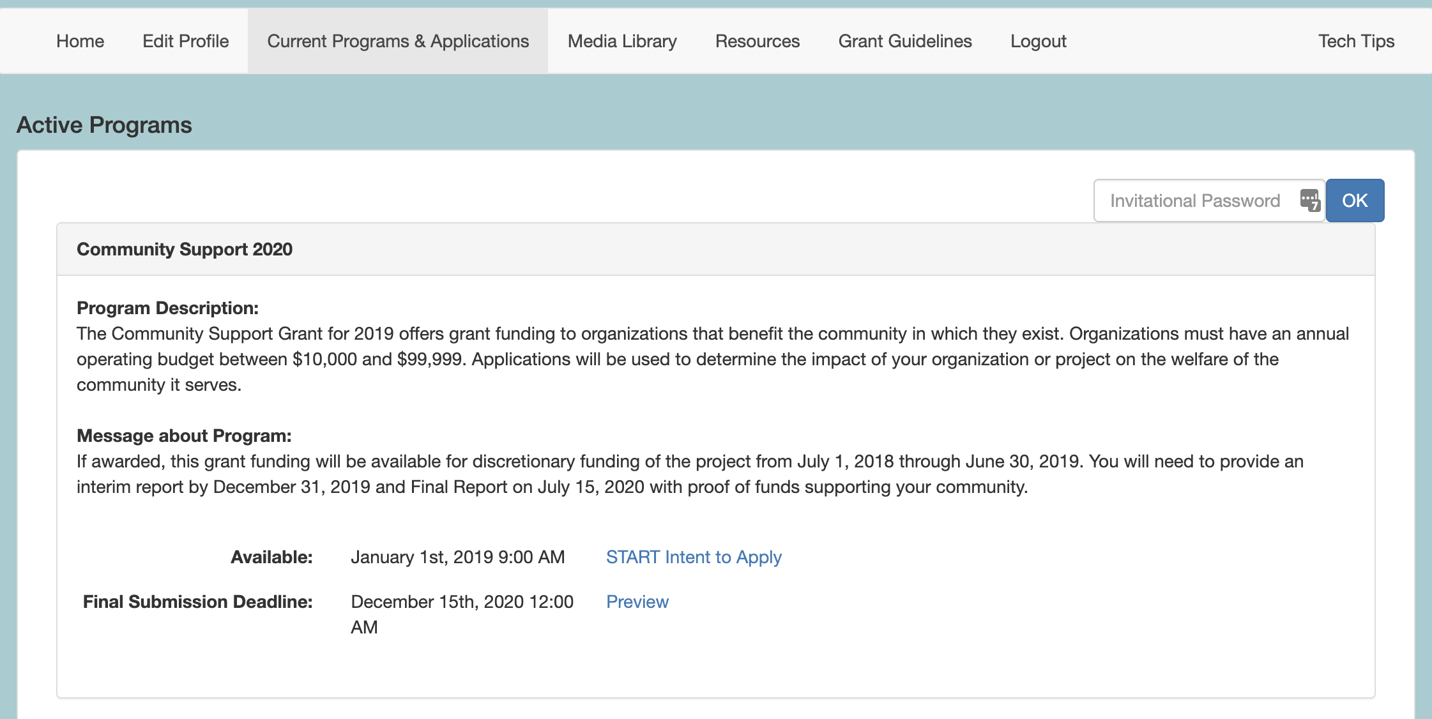
- Navigate to the Current Programs & Applications tab to begin working on your application, intent to apply, interim, or final report.

- Scroll through your list of available grant programs, noting the name in the gray heading along the top of each box (such as Community Support 2020 in the example above).

- Learn more about the program by reading the included description and/or message.

- If the application is currently available to you, click the START link to begin working on the form. If it is not yet available, you can click on the Preview link to view a read-only version.

WORK ON AN EXISTING APPLICATION

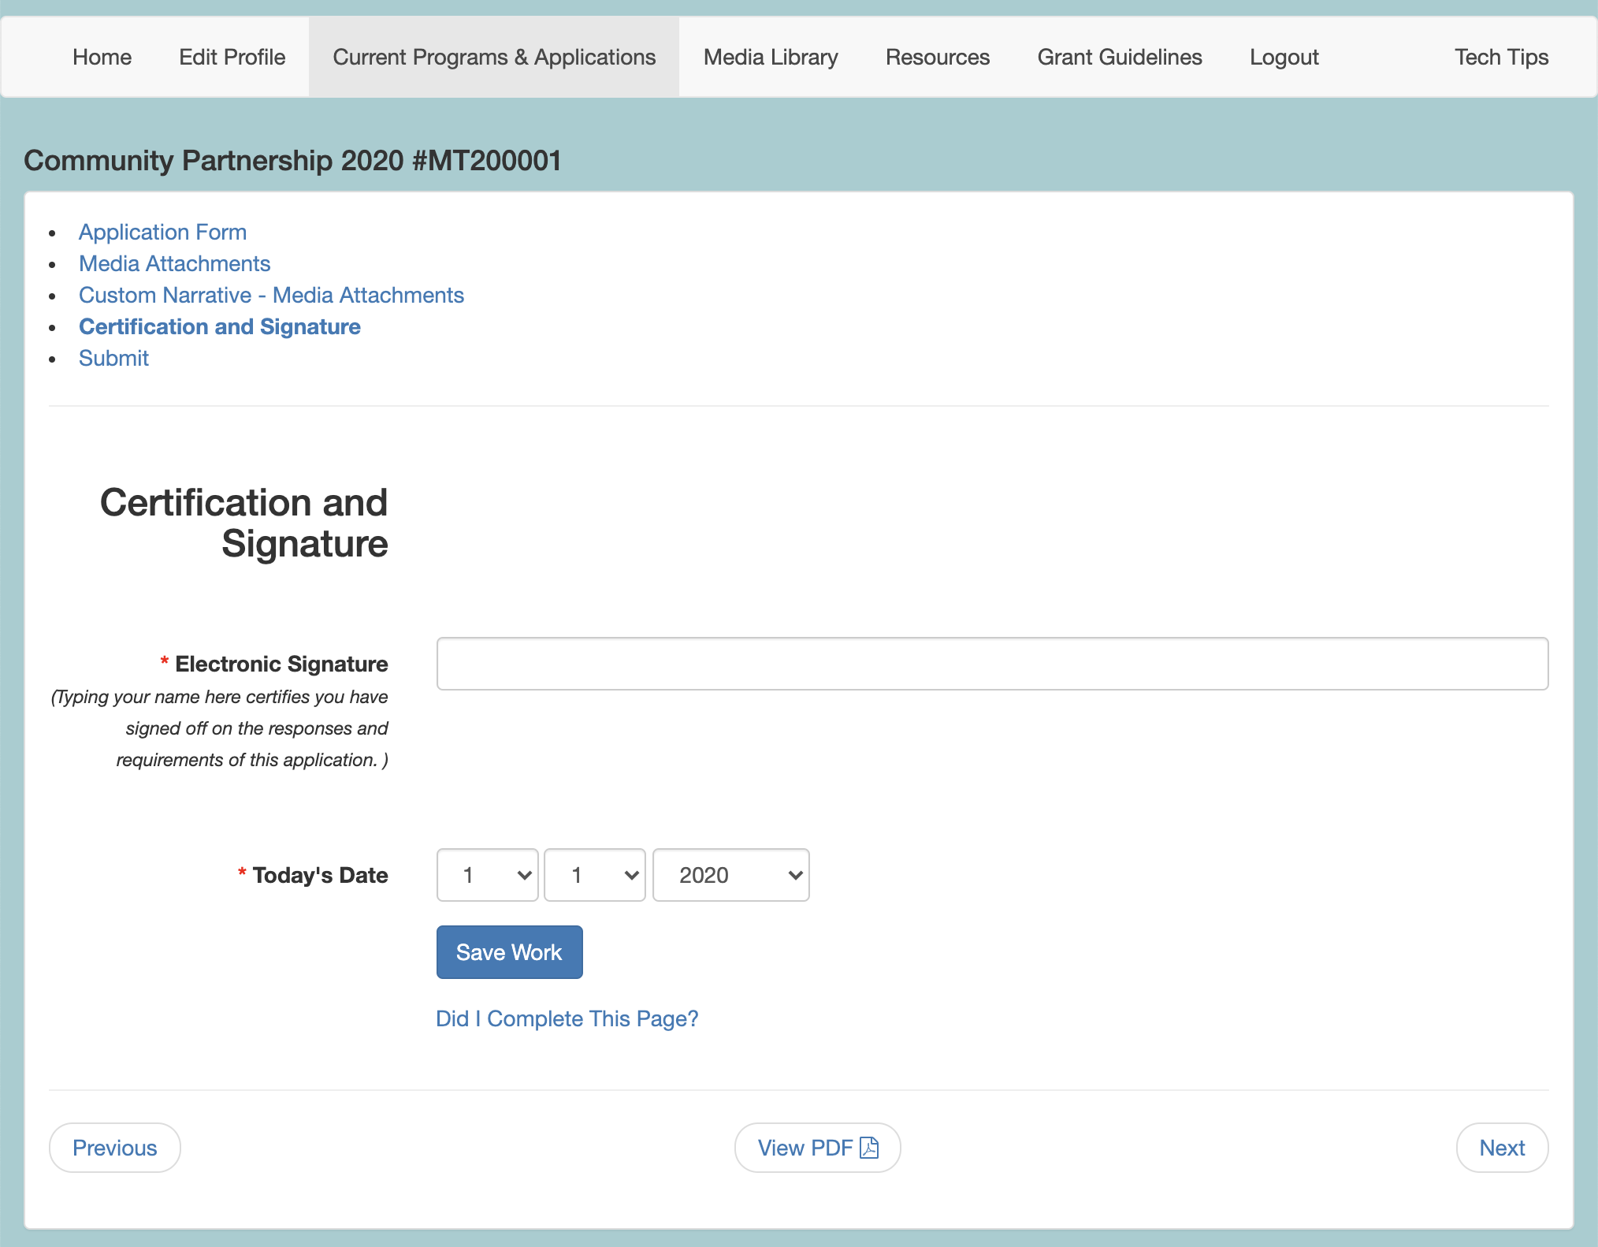
- Navigate to your grant program from the Current Programs & Applications tab. Select START or EDIT for the application item you want to work on. You can work on Intents to Apply, Applications, Interim Reports, and/or Final Reports (aka forms). Alternatively, there may be corresponding items such as Reimbursement Requests or Invoices that will be listed as separate programs on the Current Programs & Applications tab. You will be provided the name of these items if you should be looking for them.

- Navigate through the form by using the Table of Contents OR by using the Previous and Next buttons at the bottom of the page. Your application will look different than the short example above.

- Click Save Work at the bottom of EVERY page before clicking Previous, Next, or the title of a different page in the Table of Contents.

- Where available, click the "Did I complete This Page?" link at the bottom of any page to check if any required item was not answered.

- Use the View PDF button at the bottom of any page to view your application exactly as admin and panelists will view your application.

- Submit your application item on the final page of the table of contents. Once you submit the item it becomes Read-only and can only be edited upon request to your granting agency.

MEDIA LIBRARY SELECTION PAGE

One of the pages within your application may give you the opportunity to use an Attach [Media] button, as shown in the example below. If you see these buttons you are on a Media Library Selection page. In order to utilize this page, you will need to upload files to your Media Library that you will then attach to this page. Within the application, this page may be called Media Attachments or something similar such as Support Materials, Work Samples, etc.
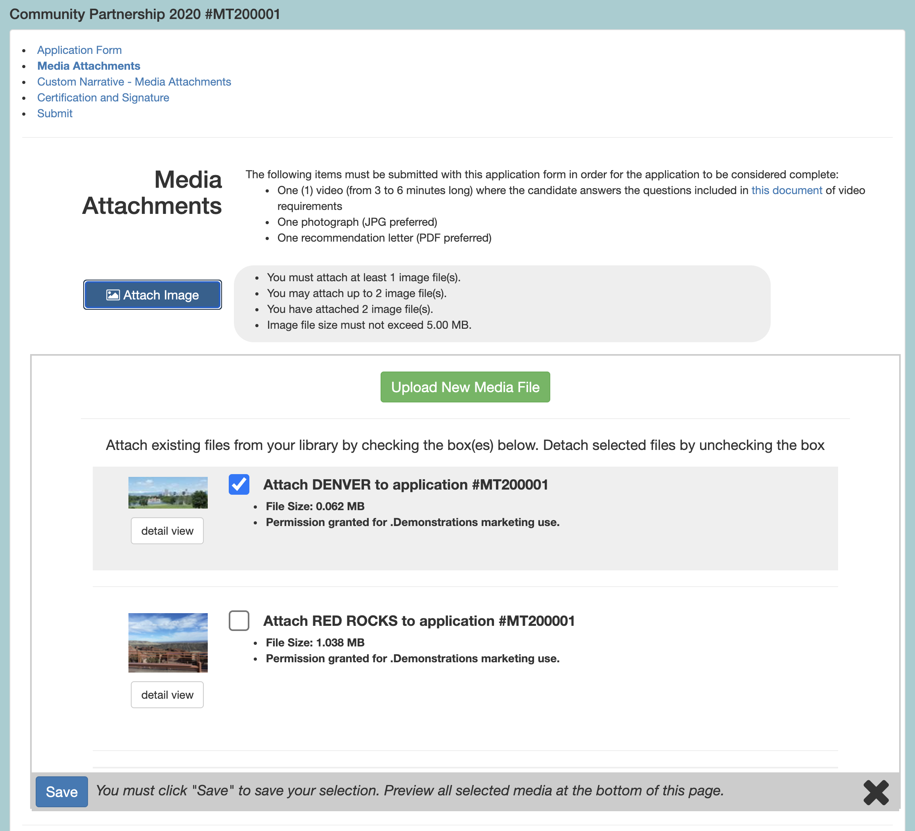
- Click any of the Attach [Media] buttons (ie. Attach Image, Attach Audio, etc.).
- Check the box for the desired file(s). Uncheck a box to detach the file.
  - If you have not yet uploaded your desired media to your Media Library:
    - Click the green Upload New Media file button. This will take you to the upload form in your Media Library.
    - Follow the Media Library instructions to upload your file(s). Upload or modify additional files while in the Media Library.
    - Click the Return to Application button to return to your application, interim, or final report.
    - Click the Attach [Media] button.
    - Check the box for the desired file(s).
- Click Save.
- Repeat as needed for each media type
- Review the Attached Media section at the bottom of the page to verify your selection.

TROUBLESHOOT MEDIA LIBRARY
Learn how to use the tools of your library.

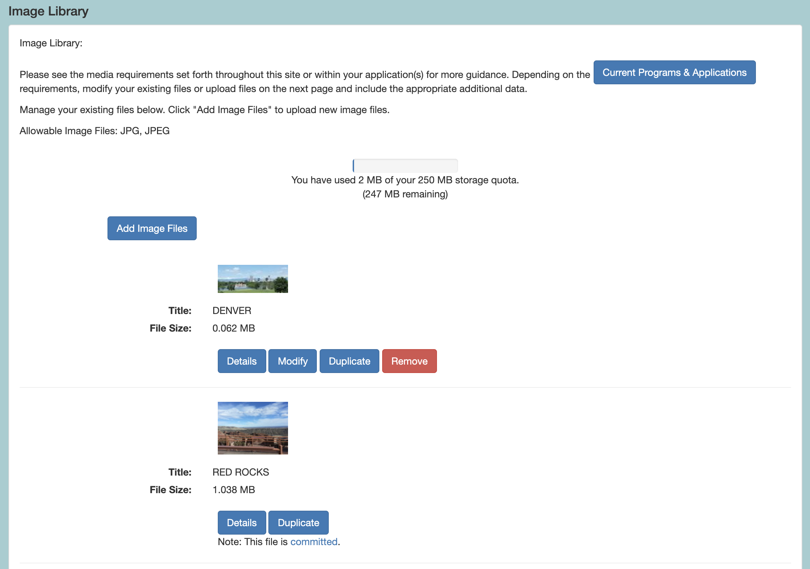

- Use the Details button to review information you included when you uploaded the file.
- Click Modify to edit and save any changes to an existing file.
- Click Duplicate to make a copy of a file.
- Click Remove to delete an existing file from your Media Library. This will free up space to upload additional items.
- If Modify and Remove are not available and you see that the file is committed (as in the second example above), this indicates that the item is currently attached to an application that is In Progress. If you need to modify or remove the item, you will need to either submit the In Progress application or detach the item from the In Progress application.
- Alternatively, you can duplicate the committed item, update the details, change the name, save and attach the modified duplicate to the appropriate form on a Media Library Selection page.

NEXT STEPS

If you are instructed to submit additional reports or forms after submitting your application, follow the steps below to find the appropriate items.
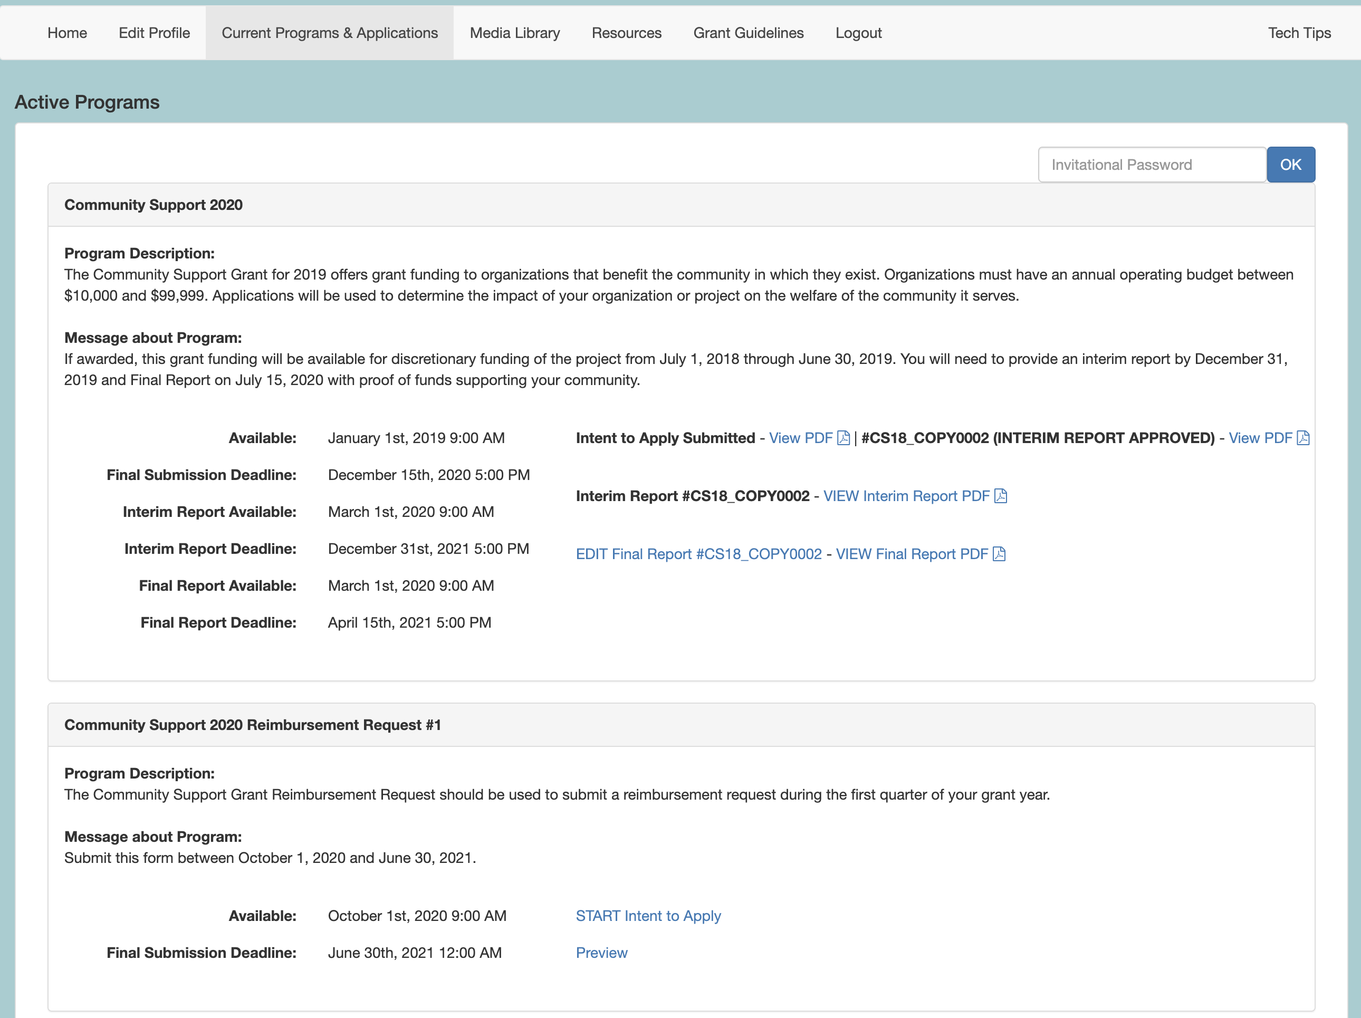
- Watch for communications regarding a possible award, necessary follow-up reports and other items.

- If you are awarded or invited to work on follow up items such as interim or final reports, return to your Current Programs & Applications tab, locate the cycle and click START or EDIT on the available cycle item, such as the Final Report in the top example above.

- Alternatively, you may be directed to associated programs, such as Community Support 2020 Reimbursement Request #1 in the bottom of example above. Locate this associated program and click START or EDIT to work on and submit the appropriate item.

HELP AND GUIDANCE

The Home page of this site is customized to include information you may need when working on your grant programs (see generic example shown below). You may also see custom navigation pages, such as Applicant Resources. These pages may include additional guidance regarding the way you should use the site.
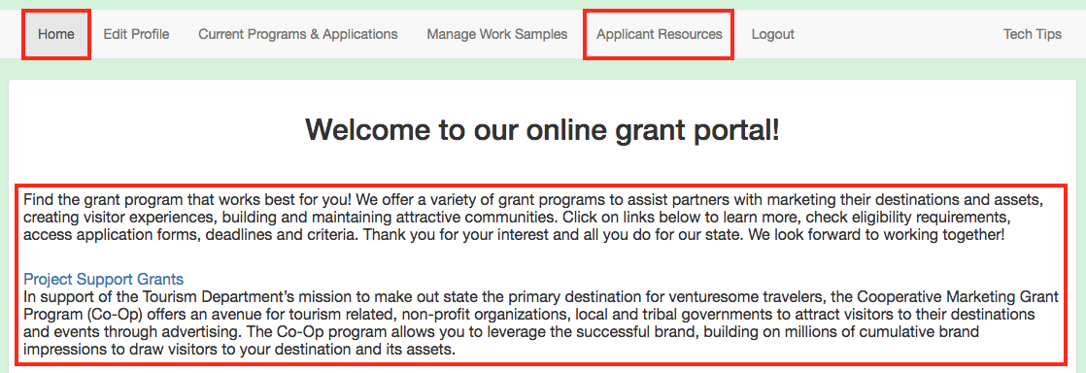
- Follow any guideline or rules as set forth in these areas, shown in the example above.

- If there is no additional help language or navigation pages, navigate to the Current Programs & Applications tab to begin working on your grant(s).

For additional information and assistance while using the GO Smart site, please contact the granting agency.

